OUR PRODUCTS
Introduction
At Al Baraqah Global Exports, our product portfolio is built around controlled sourcing, structured grading, and compliance-driven export execution.
We specialize in supplying high-demand agricultural commodities that meet international import standards, moisture parameters, and commercial specifications.
Each shipment is handled through defined procurement protocols, quality verification processes, and export documentation control to ensure reliability for global buyers.
TAB 1: RED CHILLI
India is the world’s largest exporter of dry red chillies. We supply carefully graded, moisture-controlled, export-ready chilli varieties sourced directly from major producing regions in Andhra Pradesh and Karnataka.
All chilli shipments are sorted, inspected, and packed according to international trade standards.
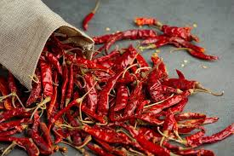
Variety – 1 : GUNTUR MIRCHI
( Guntur Sannam Chilli )
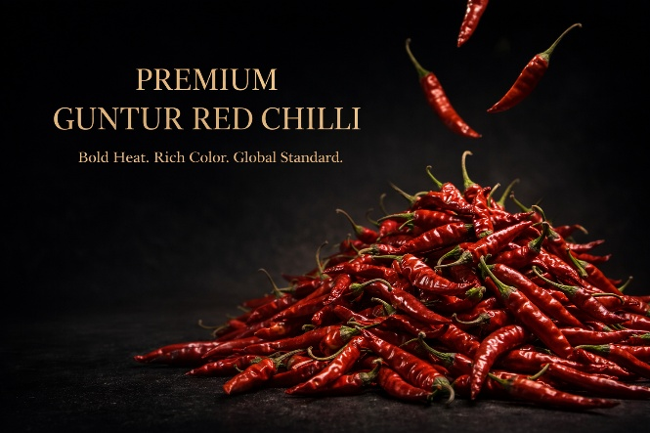
What Makes This Variety Special
Guntur Mirchi is one of the most traded chilli varieties globally. It offers a balanced combination of strong pungency and deep red color, making it highly suitable for industrial spice processing and bulk trade markets.
Primary Uses
• Chilli powder manufacturing
• Spice blending units
• Oleoresin extraction
• Processed food production
• Wholesale spice distribution
Buyer Benefits
• Stable pungency range suitable for industrial processing
• Consistent color retention during grinding
• High demand in wholesale markets
• Reliable year-round procurement
• Suitable for both whole trade and value-added processing
Consumer Benefits
• Enhances flavor intensity in food
• Provides natural heat without artificial additives
• Rich in capsaicin content
• Contributes to metabolism stimulation
• Long shelf stability when stored properly

Export Specifications
• Pungency: 35,000 – 40,000 SHU
• Moisture: Below 12%
• Form: Whole / Stemless
• Grades Available: 341 / 334
• Packing: 25 kg / 50 kg PP Bags
• Bulk container loading available
Quality Process
• Direct sourcing from verified production belts
• Batch-wise grading and size segregation
• Moisture testing prior to packing
• Pre-dispatch inspection
• Supervised container loading
• Export documentation verification before shipment
BYADGI MIRCHI
( Byadgi Chilli )
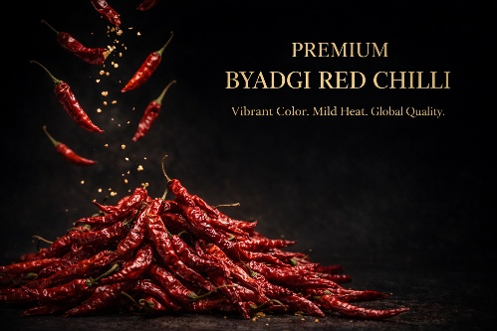
What Makes This Variety Special
Byadgi Mirchi is internationally recognized for its high ASTA color value and mild pungency. It is preferred in markets where vibrant red color is commercially more important than heat intensity.
Primary Uses
• Premium chilli powder production
• Natural food coloring
• Paprika extraction
• Sauce and gravy manufacturing
Buyer Benefits
• High ASTA color value suitable for premium markets
• Low pungency allows broader consumer acceptance
• Strong visual appeal in powdered form
• Ideal for color-focused spice blends
• Consistent grading for industrial processing
Consumer Benefits
• Enhances natural red color in food preparations
• Adds mild heat without overpowering flavor
• Suitable for households preferring balanced spice
• Improves visual presentation of curries and gravies
• Retains color even after cooking
Export Specifications
• Pungency: Low to Medium
• Moisture: Below 10–12%
• Form: Whole / Stemless
• High ASTA color batches
• Standard export packing available
Quality Process
• Color-based batch segregation
• Controlled drying validation
• Moisture verification before dispatch
• Manual and machine sorting
• Lot identification and traceability
TEJA MIRCHI
( Teja Chilli )
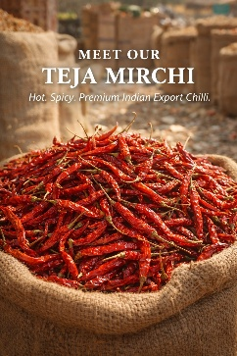
What Makes This Variety Special
Teja Mirchi is one of the hottest commercial chilli varieties exported from India. It is widely demanded in high-heat spice markets due to its elevated capsaicin levels.
Primary Uses
• Hot sauce manufacturing
• Spicy processed foods
• High-heat spice blends
• Bulk chilli powder production
Buyer Benefits
• High SHU range suitable for heat-focused products
• Strong aroma and spice intensity
• Suitable for blending with milder varieties
• Strong demand in Asian export markets
• Consistent pungency control for processing
Consumer Benefits
• Delivers strong and authentic spicy flavor
• Enhances heat profile in food preparations
• Ideal for consumers preferring high-spice cuisine
• Adds intensity to sauces and marinades
• Maintains flavor strength even after cooking
Export Specifications
• Pungency: 50,000+ SHU
• Moisture: Below 12%
• Form: Whole
• Sun-dried
• Bulk packing options available
Quality Process
• Pungency-based batch control
• Field-level sourcing validation
• Moisture confirmation before container sealing
• Supervised export packing

RICE
At Al Baraqah Global Exports, our rice division operates under structured procurement protocols, supervised milling controls, and defined export compliance frameworks.
We supply internationally traded rice varieties aligned with global import standards relating to grain length, moisture parameters, broken percentage, aging consistency, and packaging integrity.
Each shipment is executed with documented quality verification and controlled export handling.
TRADITIONAL BASMATI RICE
(Traditional Basmati Rice)
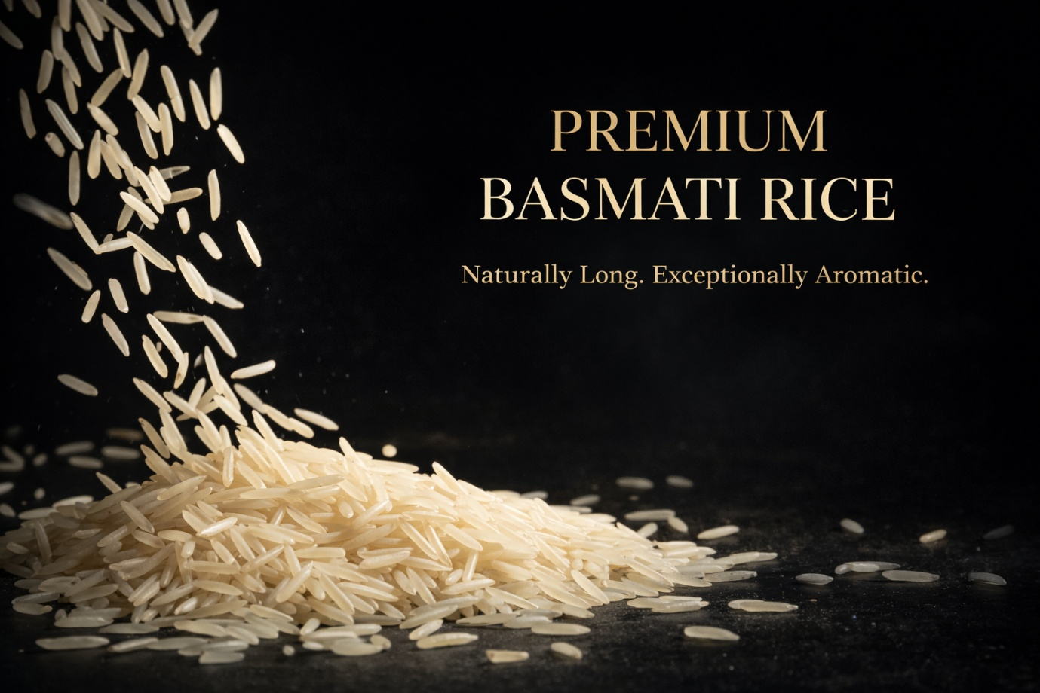
Variety Profile
Traditional Basmati is a heritage long-grain aromatic rice cultivated in the Indo-Gangetic plains. It is globally recognized for its natural fragrance, elongated grain structure, and premium culinary positioning across international markets.
Commercial Positioning
This variety is typically supplied to premium importers, hospitality distributors, and branded retail segments seeking authenticity and high aroma retention.
Industrial Applications
• Premium retail packaging
• Hospitality and fine-dining supply
• Private label programs
• Specialty food distributors
Buyer Advantages
• Premium-grade long grain structure
• High aroma retention after cooking
• Strong brand positioning potential
• Stable demand in Middle East and European markets
• Suitable for value-added retail packaging
Consumer Advantages
• Naturally aromatic profile
• Distinct long-grain elongation after cooking
• Non-sticky texture
• Refined dining quality
Technical Product Parameters
Grain Length: Long and slender
Broken: 1% / 2% / 5% (as specified)
Moisture: < 14%
Aging: 12–24 months available
Variants: Raw / Steam

Export Specifications
• Retail packing: 5 kg / 10 kg
• Bulk packing: 25 kg / 50 kg
• Private label branding support
• Moisture-controlled warehousing
• Containerized bulk shipments
Quality & Process Control
• Supervised milling operations
• Grain length and broken validation
• Moisture verification prior to packing
• Aging confirmation where applicable
• Pre-shipment inspection protocols
• Structured documentation and compliance review
• Container loading supervision and seal verification
SONA MASOORI RICE
( Sona Masoori Rice )
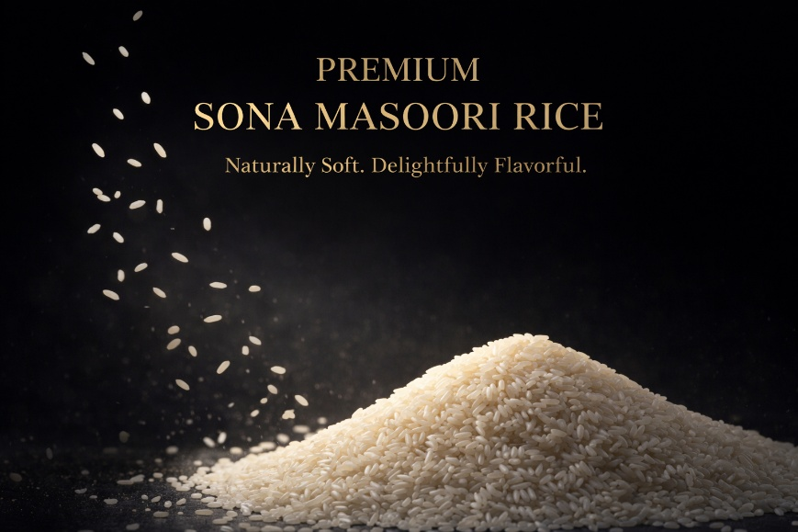
Variety Profile
Sona Masoori is a medium-grain rice variety cultivated primarily in South India. It is positioned as a high-volume staple rice for retail and institutional consumption across export markets.
Commercial Positioning
This variety serves bulk distributors, supermarket chains, and institutional buyers requiring consistent grain uniformity and scalable supply capacity.
Industrial Applications
• Retail supermarket distribution
• Institutional catering
• Food service operators
• Regional wholesale markets
Buyer Advantages
• Reliable bulk procurement volumes
• Competitive price positioning
• Consistent grain size uniformity
• Suitable for high-turnover markets
• Scalable export supply
Consumer Advantages
• Soft texture after cooking
• Easy digestibility
• Balanced starch profile
• Suitable for daily consumption

Technical Product Parameters
Grain Type: Medium grain
Broken: As per buyer specification
Moisture: < 14%
Variants: Raw / Steam / Parboiled
Export Specifications
• 5 kg / 10 kg retail packing
• 25 kg / 50 kg bulk packing
• Private label capability
• Moisture-controlled storage
• Containerized export shipments
Quality & Process Control
• Grain uniformity inspection
• Broken percentage verification
• Moisture testing prior to dispatch
• Supervised milling process
• Batch traceability
• Export documentation control
• Container supervision and compliance checks

